WITNESS STATEMENT
Student Name:

Programme: | Diploma for IT Practitioners

Unit Title: | Communication Technologies | Unit Number: | 10

Which part(s) of the unit have been met? |  | Observation Notes:  How student’s performance met the requirements of the specification - Student did the following:
P7

How and where the activity took place? | In the workshop using a networked computers plus coursework evidence

Witness signature: | 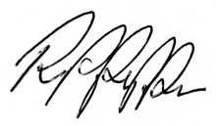 | Date:

Witness name: | Richard Pfeiffer (lecturer) | Tel No: | 020 8200 8300

